OUTPUTS

CASE 1: BOOKING OF TICKET

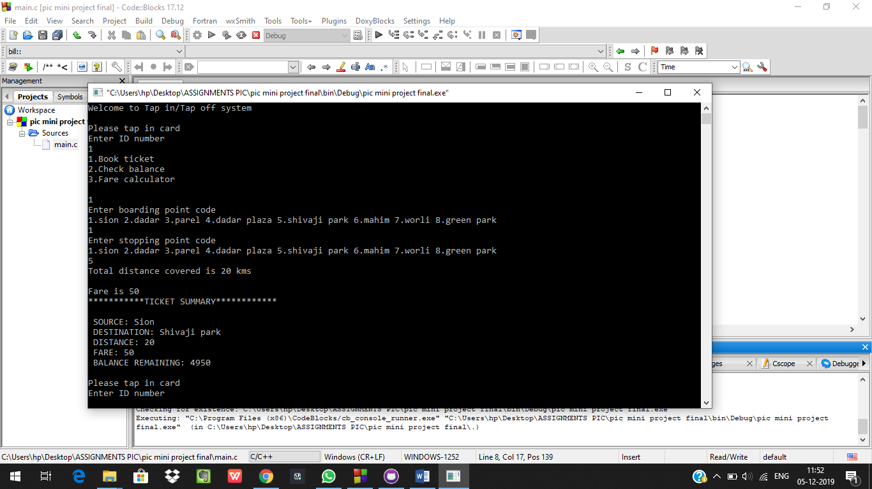

CASE 2: CHECKING OF BALANCE

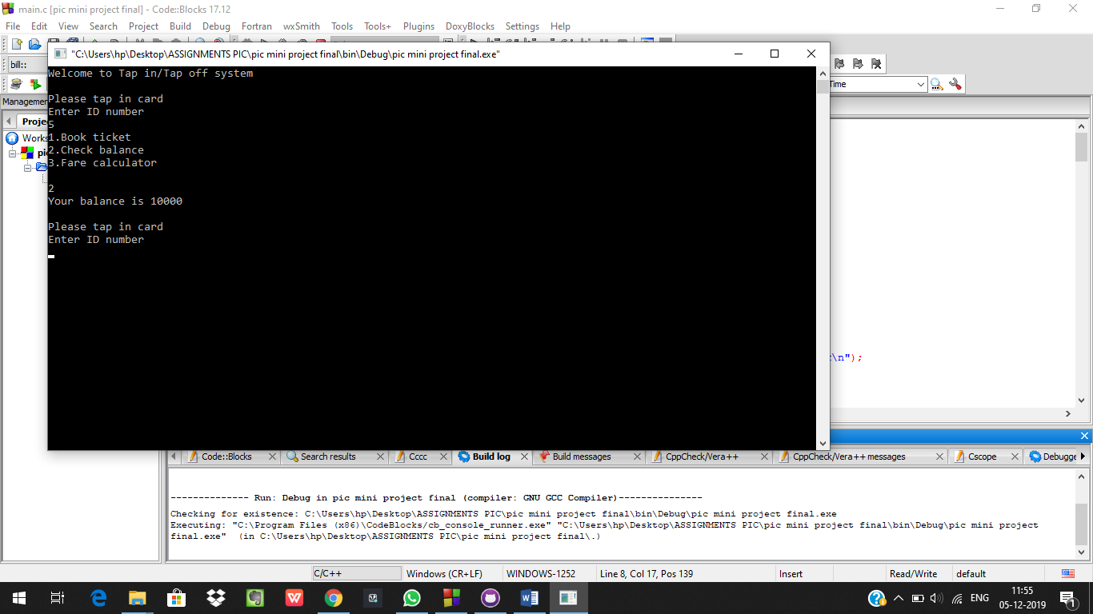

CASE 3: CALCULATION OF FARE

